PROPOSAL FOR THE BUILDING OF A ROBUST TAXI BOOKING APPLICATION

BY

TENTACULAR INVESTMENT LIMITED

CLIENT : J-RIDE

ABSTRACT
Hiring taxi has been a challenge as the fact that the immediate availability and the arrival time is uncertain. Manual method of hiring taxi has lots of disadvantages. First of all, we may not know when the taxi will arrive.
Secondly, the fare may be unsure depending on the driver.
Thirdly, if we are in unknown places then we might not know the
distance and right fare.

It has been a long wish of people to hire taxis at their comfort at anytime from anywhere. Taxi hiring application reduces the tension of people to hire a taxi. User can book a taxi by just clicking few options on mobile phone. Fare is automatically calculated with pick up and drop information which reduces manual error as well as removes the doubt of irregular charges while hiring taxi in unknown places. Taxi hiring mobile application has lots of scope in the market since it meets the day-to-day need where transportation plays a major role. With smartphones in the hand, user can simply click on few options and book
or cancel taxi. The number of users of taxicab application is increasing consistently leading to development of multiple apps for taxicab hiring application.
One has to verify different features available with the application before choosing the right application. The quality of application depends upon the technology used and how it is handled.

Objectives

- Reduce waiting time.
- Locate taxi based on GPS locator.
- Book or cancel the booking of taxi easily.
- Push notification about booking or cancellation.
- Automatic calculation of taxi fare.
- Star rating of taxi service or driver providing feedback.
- Pick up spot and destination place known early for taxi drivers.
- Taxi drivers can choose the best route to reach destination.
- Flexible payment method via credit card or cash

System Overview for Riders and Drivers

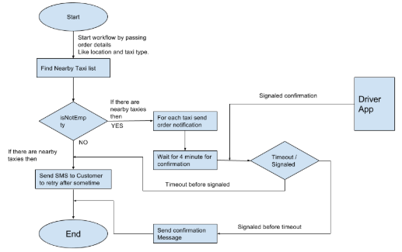

- Splash Screen
- Registration/Login Screen
- Home Screen
- Side Menu

- Splash Screen: This is the first screen a user see, when the app is launched for the first time. It features a background with the company logo.
- Registration Screen: This screen as the name implies have to do with data collection of both riders and drivers.
  - Rider Registration: Registration would feature input fields to collect data from the riders. It includes the first and last name, phone number, email and password.
  - Driver Registration: Registration for drivers would also feature input fields to collect their data. It includes the first and last name, phone number, email and password. Also as a part of verification, drivers would also be required to upload their driver’s license.
  - Login Screen: This screen gives users (riders and drivers) an access to the app.

- Home Screen: The home screen will feature a map, along with a button to access the side menu.
- Rider’s Home Screen: The rider’s home screen would feature a map, a button to access the side menu, along with tab bar showing their pickup location. Riders will be able to use their current location as a pickup location or set their pickup location from the map. The home screen would also feature a book ride button to allow the rider book a taxi nearby.

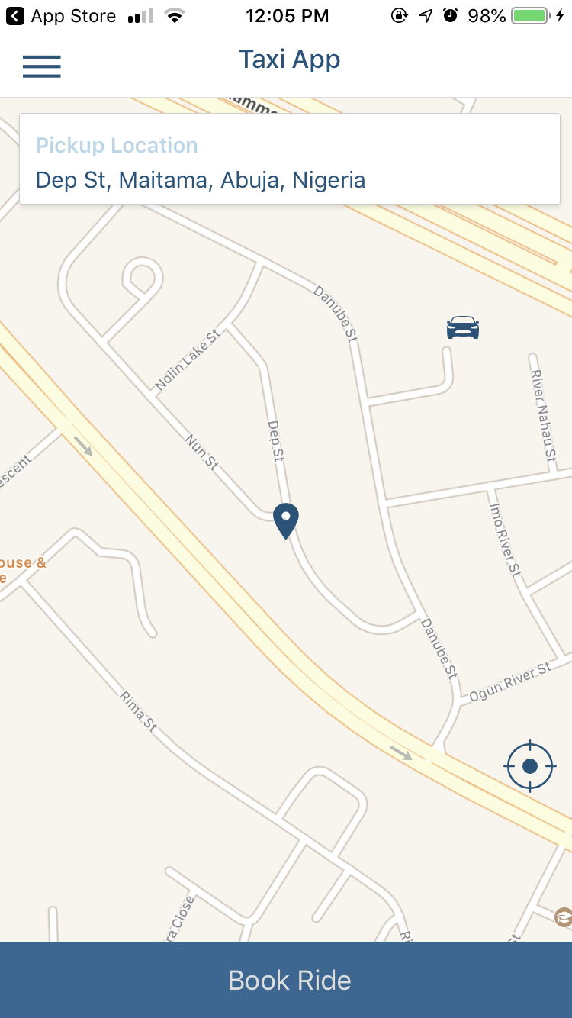

- Book Ride Button: On press of this button, the rider would be able set destination or drop off location. The rider would also be able to see the trip estimate, which shows the distance, estimated time and fare amount. The rider will also be able to select type of payment (cash or card) before requesting a ride. On request of a taxi, the rider will be connected to the closest available driver, who will accept from their driver’s app. Upon accept of the ride by the driver, the rider will have access to the driver details such as the name and car type, also with an option to contact or cancel the ride.
A feedback and rating system is available to the rider to rate the trip upon completion.
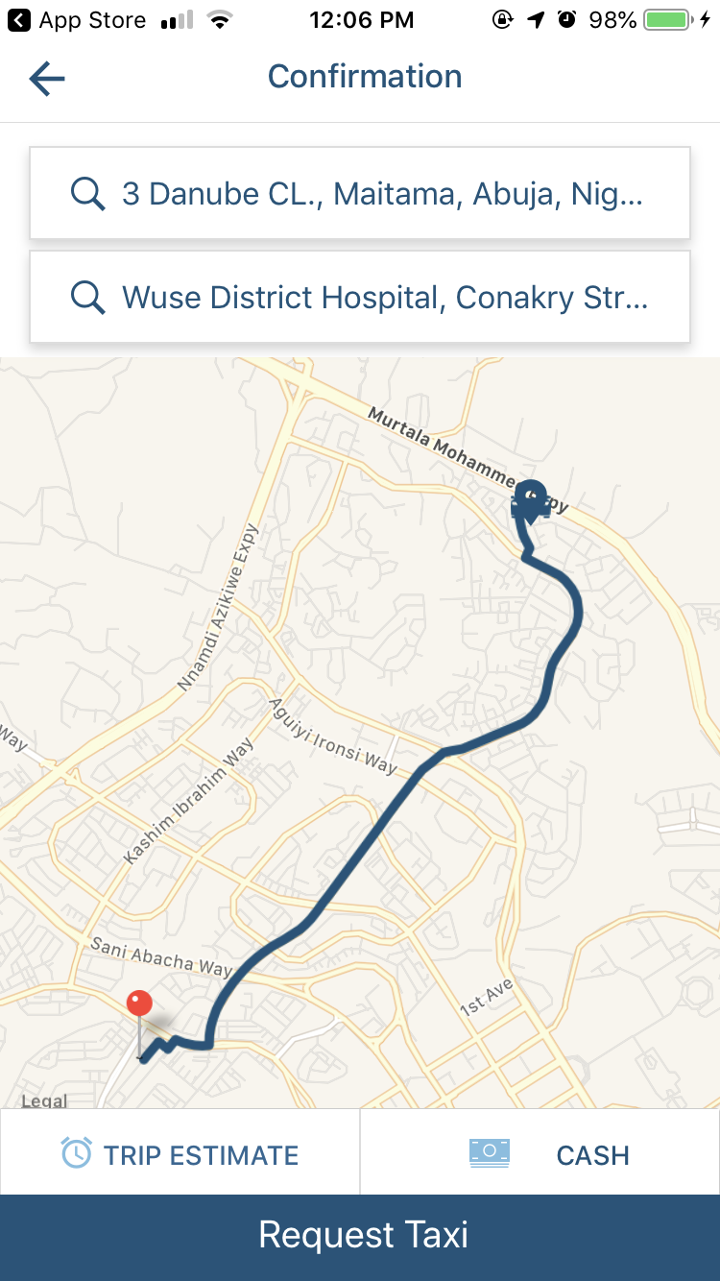
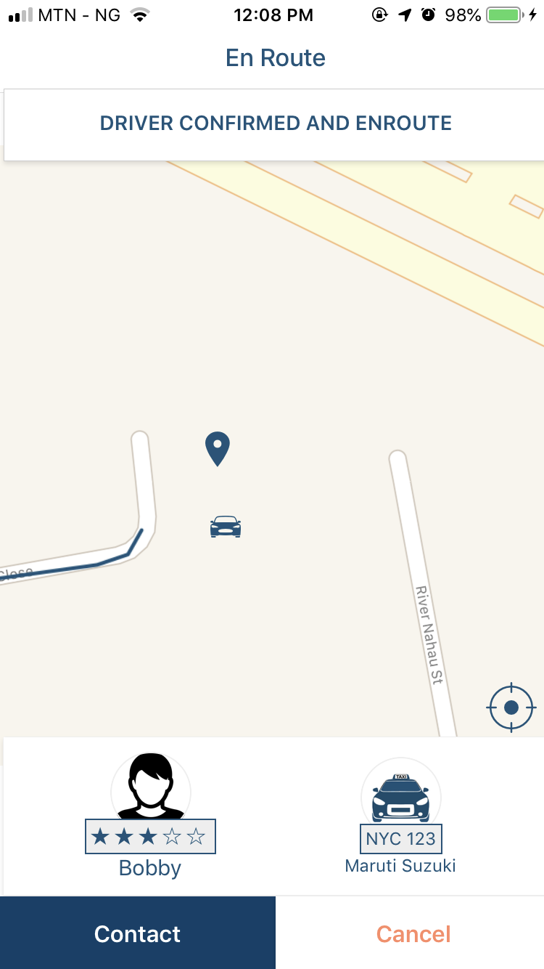

- Driver’s Home Screen: The driver’s home screen would also feature a map, a button to access the side menu and also a button to toggle availability. When a rider request for a ride, the closest available driver gets a pop up to accept or reject the request, along with a countdown timer of 10 seconds. If the driver does not select an option to accept or reject with the 10 seconds timer, the rider’s request will pop up on the next nearby driver. When the driver accepts a ride, the driver gets access to the rider’s pickup location and therefore start trip after pickup is confirmed.
The driver has a navigation direction to the rider’s destination and complete trip upon arrival.

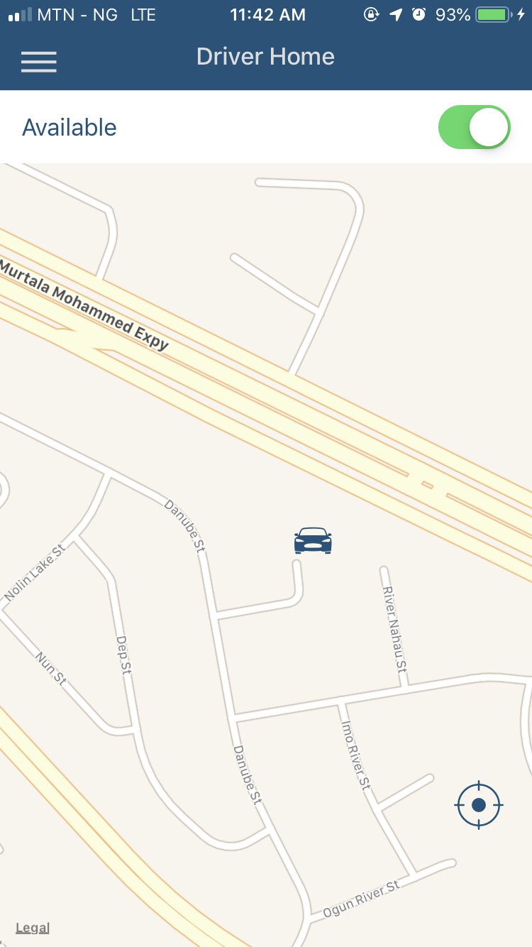

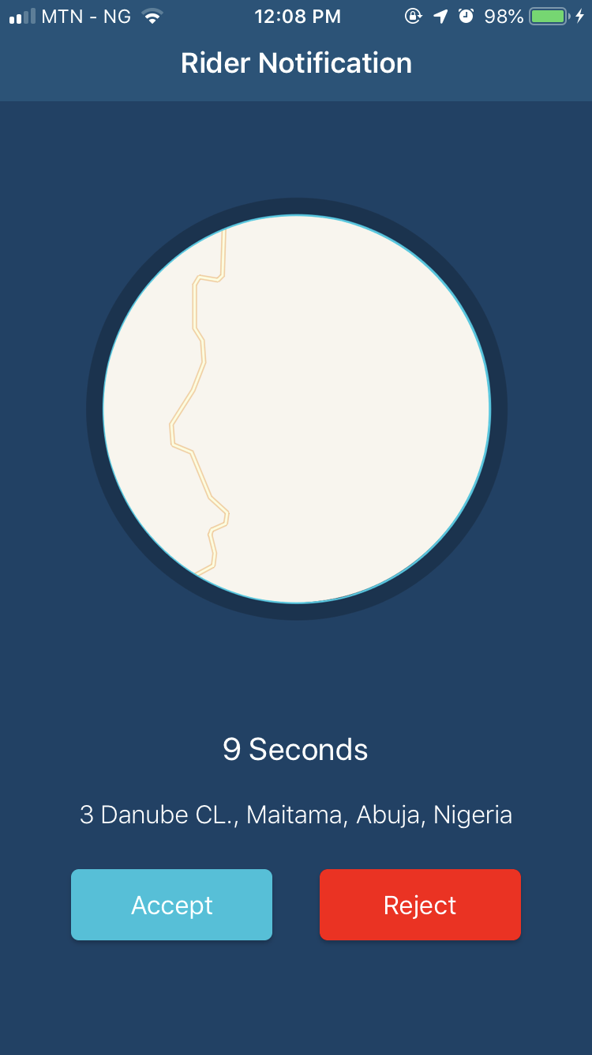
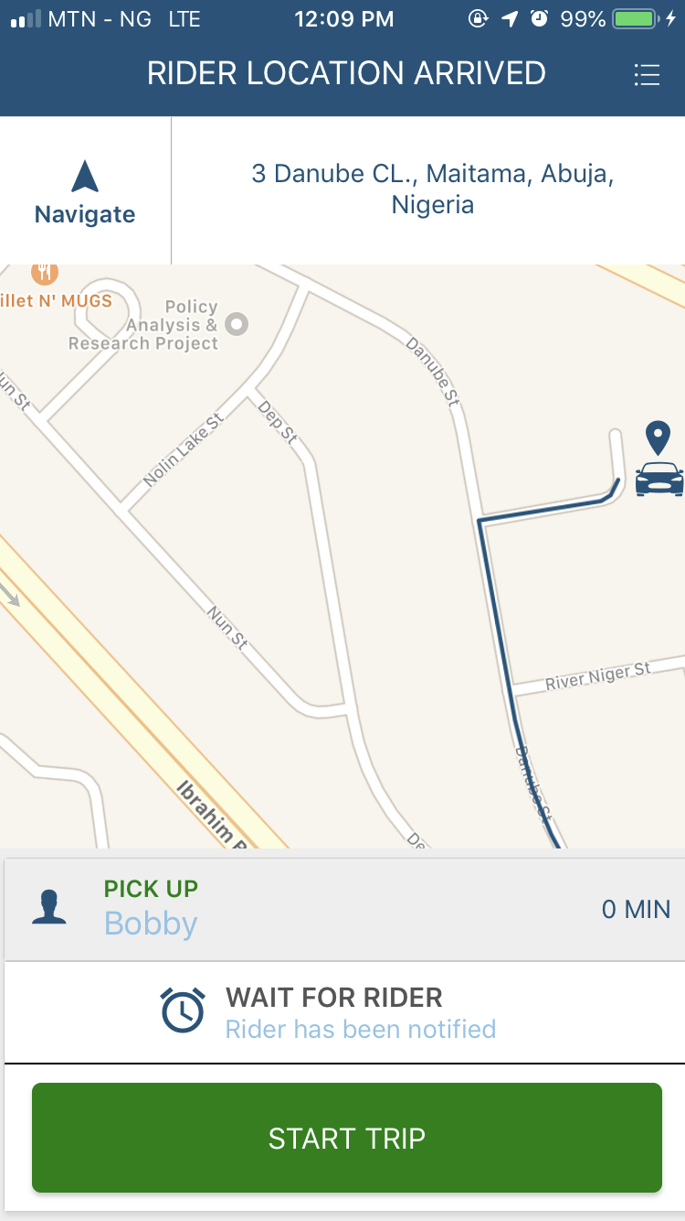

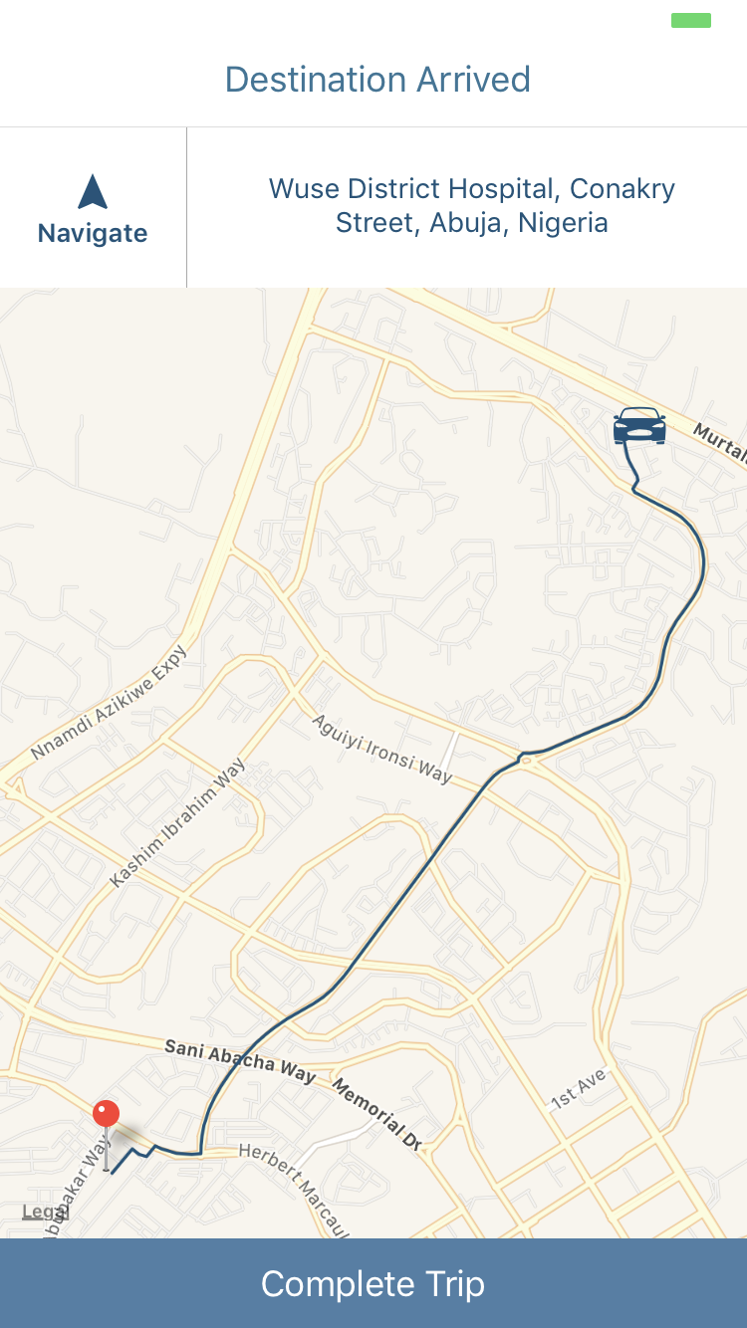

- Side Menu: The side menu will feature the following; Payment/Earnings, History, Settings and Sign Out.
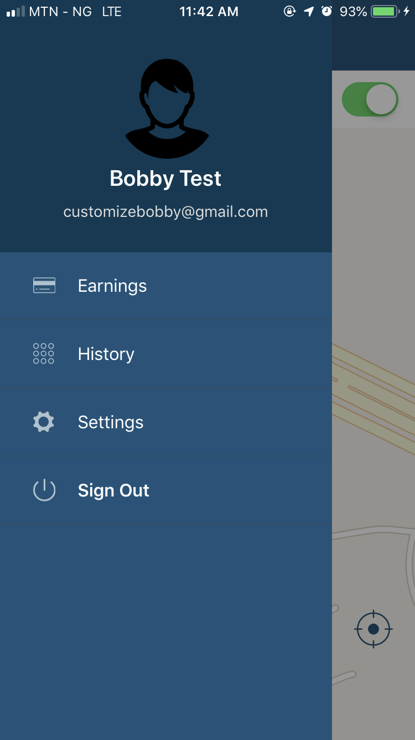
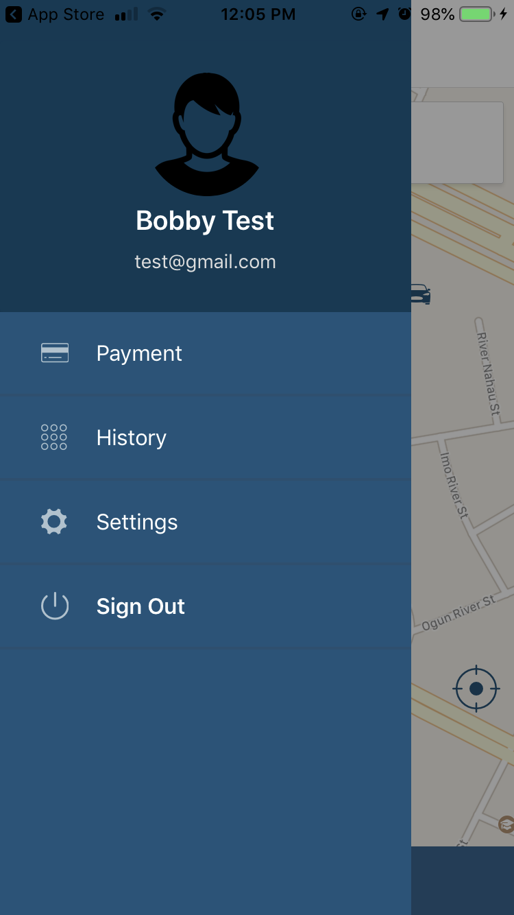

- Payment/Earnings:
- Payment: This will be featured in the Rider’s app and it will provide riders with the option to select payment type(cash or card).
- Earnings: This will be featured in the Driver’s app and it will provide drivers summary of their daily, weekly and monthly earnings.
- History: This screen features past trip history with driver/rider details, fare and trip details.
- Settings: This screen provides access to edit user details and also set favourite places such as work and home.
- Sign out: This provides users access to sign out from the app.

ANALYSIS, DESIGN AND DEEVELOPMENT

System Requirement

SL | Hardware | Minimum System Requirement
01 | Processor | 2.4 GHz Processor speed
02 | Memory | 2 GB RA
03 | Disk Space | Unlimited

SL | Software | Minimum System Requirement
01 | Operating System | Linux
02 | Database Management System | MongoDB
03 | Language | React Native, Java, Objective-C, JavaScript

System Development
We would use Bracket IDE, React Native, and for data storage we would use MongoDB.

Financial Implication and project duration:
This project is expected to be executed in the space of 10 weeks, which would
6weeks for building and 4 weeks for testing and bug fix, the project commence immediately after the payment of 50% of the agreed sum.

4.3 Pricing and Payment Terms
ITEM | COST (NGN)
Cloud hosting and domain name
.net,.com, .ng, .com.ng,.org etc | 300,000 (Yearly)
Android / ios store | 180,000 (One Off)
Google Cloud Server | 800,000 (Yearly)
Development & Deployment
2 Android Applications | 400,000 (One Off)
2 IOS application | 400,000 (One Off)
1 web control panel | 200,000 (One Off)
Advert And Maintenance
Advert
Social media | 30,000 (monthly / first month free)
Maintenance
Maintenance | 100,000 (monthly / first month free)
Total | 2,280,000

Payment Terms:
- 50% of payment to be made before development
- 50% balance after deployment ( Could be paid in two batches )

CONTACT DETAILS
You can get in touch with us in any of the below ways:
By Phone:
08083430800
By Email:
kingsonly13c@gmail.com
On our website:
www.tentacularltd.com
By post:
House-54/A, Off Ibrahim Isiyaku Street, Mabushi, FCT

